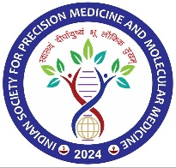

**(Soc. Reg. Act 1860 Reg. No. GOR/02575/2024-25)**

**APPLICATION FOR MEMBERSHIP**

To,

The President

Indian Society for Precision Medicine and Molecular Medicine (ISPMMM)

I wish to become a General Member (Annual) / Life Member/Special Member of the Association. I enclose herewith the Membership fee INR...................………. (In words……………………………………….)By UPI/ NEFT/ IMPS/Cash / Demand Draft/ drawn in favour of “Indian Society for Precision Medicine and Molecular Medicine (ISPMMM) on…………………………….. Bank,.........................................………………………………………………………………Branch, UPI/NEFT/IMPS/DD, and transaction number/Ref No………………….............................................., Date…. ……………………., as my membership contribution.

**Particulars of Member:**

Photo

Name in Full (in block letters):

Father’s Name………………………………………………ADHAR CARD No……………………………….PANCARD ID……………………….

Academic Qualifications:

Institutional Affiliation and Years of Experience:

Field of Specialization:

Office Address:

Office Contact No.………………………………………E-mail:…………………………………..

Residential Address:

Res. Contact. No:

Introduced by…........................................................................................................................................ Date……………………………………………………….Signature……………………………………………………………………….

(For Office Use Only)

Remarks……………………………………………………………………………………Application No…………………

Admitted on………………………Membership number……………………,......................Receipt No.....................................

Date……………………………………………… Signature, President, ISPMMM

**MEMBERSHIP**

**Life Members:** This membership is applicable for lifetime and can be taken by anyone (pursuing or having MD, MS, MCh, DNB, DM, PhD, and Post-doctorate Fellowship), scientists, and faculty members of universities, IITs, AIIMS, medical colleges, and research institutions, with the exception of special members.

**General Membership:** This membership is for **student category** up to 30 years of age who are studying in related fields. This membership is active until the **completion of an MBBS** (or any other comparable medical courses) and postgraduate studies leading to an **MSc (Medical or Life Science).** The same membership applies to **Annual Membership category,** which is a one-year membership for individuals who do not fall under the student category and are interested in joining the society for a year.

**Special Members**: Firms involved in any discipline of Treatments/Research/Instruments, Kits development/sales/ and related ventures; who have shown sustained interest in the field.

**Honorary Members:** Clinicians/ Scientists of National and International repute are invited to become honorary members of the Association.

|  |  |  |
| --- | --- | --- |
| **Subscription** | | **Membership fee** |
| **Life Members** | | India: 5000/- |
| **#General Members** | Annual Members | India: 1,000/- |
| Student Members |
| **Special Members\*** | | India: 10,000/- |

#General member category is for student membership, as per above mentioned and also for the annual membership- for anyone interested to be member of society for one year.

* Firms involved in any discipline of Treatments/Research/Instruments, Kits development/sales/ related who have shown sustained interest in the field

**Note:**

1. Any change in communication address should be communicated immediately to ISPMMM Secretariat.
2. I acknowledge and agree to abide by the rules of the society, and I understand that any violations on my part may result in the cancellation of my membership, to which I will have no objections.
3. Bank details for the NEFT,IMPS, UPI, DD or wire transfer payment:

|  |  |
| --- | --- |
| Name of Society | Indian Society for Precision Medicine and Molecular Medicine |
| Bank Address | SBI Girdharganj Branch, Gorakhpur |
| Account No. | 43342466949 |
| IFSC Code | SBIN0018457 |
| MICR Code | 273002056 |
| Swift Code | SBININBB497 |

QR Code: Indian Society for Precision Medicine and Molecular Medicine

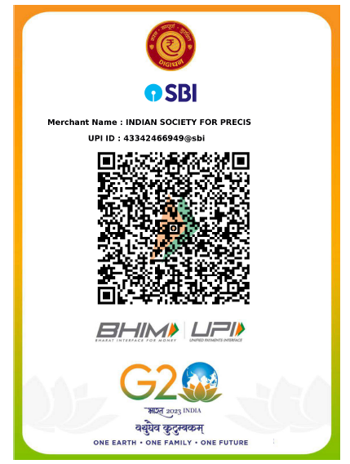

**Mailing Address:**

Dr. Shailendra Dwivedi

Indian Society for Precision Medicine and Molecular Medicine

Department of Biochemistry,

All India Institute of Medical Sciences Gorakhpur-273008

Contact No: 8003996873

E-mail: ispmmm2024@gmail.com